Archaeological and Historical Background

[
Provide a description of the archaeology within the main site. Interpret the relevance of sites in general, and in your own words. Remember to provide a grid reference for each feature or site.
You may find it easiest to present this information in a table, but you should still provide a narrative explaining what is there. Relevant (but not exhaustive!) historical information pertinent to the sites and the area. Detail any archaeological fieldwork that has previously been carried out on the site. From the information you have gathered, how has the character and use of the landscape changed over time? Illustrate this with contemporary maps and plans if possible.
Length approximately 1500 to 2000 words
]
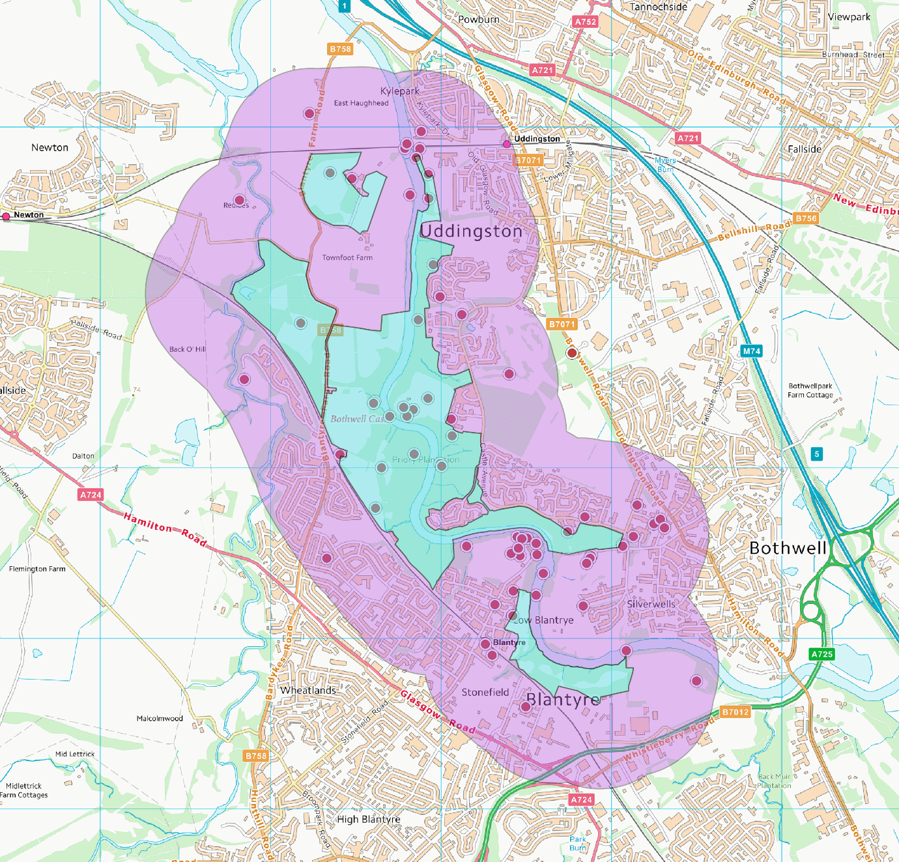
Figure 1
This background study is restricted to the area shown in Figure 1 which is formed by the Blantyre Bothwell Uddingston Local Nature Reserve (LNR), shaded green, together with a 500 m buffer zone round the LNR in purple.
Within the area covered by this report, prehistoric activity is recorded in two areas. There is a possible Bronze Age burial ground (Site 47) where cinerary urns and a quantity of bones were found in 1885. Today, the site of the burial ground is probably under a housing estate in Uddingston. Close by at Site 45, two cinerary urns containing human bones were found in 1907. At the other side of the LNR at Blantyre, a Bronze Age cist was found at Site 51, which contained a food vessel and the remains of an inhumation burial. The discovery was made in 1939 and is now in Glasgow Art Gallery and Museum.
There are some signs of Roman activity in the area. A large quantity of Roman copper coins was discovered in 1848 at Site 48 during the formation of the Clydesdale Junction Railway. A Roman gem, engraved with a representation of a winged genius kneeling, with his hands behind his back, was found in 1835 at Site 46 in Uddingston.

Bothwell Castle (Site 9) is one of the most significant structures in this LNR, indeed, according to Historic Environment Scotland (HES), it is one of medieval Scotland’s outstanding monuments.
https://www.historicenvironment.scot/visit-a-place/places/bothwell-castle/history/
Walter of Moray’s aristocratic family acquired the land, on which Bothwell Castle stands, in 1242 and either he or his son William built the castle. During the Wars of Independence (1296-1357) it was twice besieged and deliberately dismantled and abandoned. Its new owner, the Earl of Douglas undertook an extensive programme of rebuilding which continued into the early 15th century. In 1669 Bothwell again changed hands, this time passing to the Earl of Forfar who built a new house to the east (Site 10) and partially dismantled the castle to provide stone for the new building.
In 1935 the Earl of Home gave Bothwell into state care and it is now managed by HES as a scheduled monument. The castle is fully described, planned, and illustrated in the book by Simpson (1958).
Associated with the castle there was a park (Site 36), where the settlement Belhill was recorded on Pont’s map of 1596
https://maps.nls.uk/rec/297
It has been suggested by Anderson (1967) that there was almost certainly a deer park here.
A Canmore report describes some of the excavation work carried out near the Castle. This suggests that an informal landscape was created in the mid-19th century, together with courtyard gardens and rides. Bothwell Castle Park is described by the OS Names Book (Site 63) as ornamental grounds which in 1858 were enclosed by a high stone wall. The eastern stretch of this wall formed the side of the Hamilton & Glasgow Turn Pike road which today is the Bothwell Road (B7071). There is a Gate House (Site 54) in this wall. Much of this area is outside the LNR and some of it has been developed into housing estates but there may still be areas where traces of archaeology remain. Indeed, a geophysical survey in 2015 of an area north of the castle, described in the West of Scotland Archaeology Service report suggests that there may be buried archaeological remains and settlements in this area.
The more recent version of Bothwell Castle (Site 10), which was built with stone taken from the ruins of the original, can be seen on an OS map of 1896. It was demolished in the 20th century and a housing estate now occupies the site.

Blantyre Priory (Site 8) is, according to MacGibbons and Ross (1896-7), a house of Augustinian Canons, which was founded by Patrick, Earl of Dunbar and his wife in the 13th century. It was maintained as a cell of Jedburgh Abbey and secularised in 1598-9. In this 19th century account, the buildings are described as being in ‘poor condition and only fragmentary’.
The Priory is described in the OS Name Books as the ‘principal antiquity in the Parish’ which is ‘situated on a lofty rock on the banks of the Clyde exactly opposite the ruins of Bothwell Castle.’
Despite its importance, the Priory does not appear on early maps of the area; neither on Blaeu’s 1662 map nor on Roy’s map of 1752 – 55. However, there is a 1693 engraving by John Slezer which show the Priory and Castle as significant buildings in the landscape.
According to the OS Name Books ‘much of the ruins was demolished & carted away’ in the early 19th century by the Farmer of Craigknowe (Site 56). The proprietor, Lord Blantyre, prevented it as soon as it was known.
The blantyreproject website
https://blantyreproject.com/2013/11/the-ruined-priory/
suggests that during the mid-1950s some of the Priory was still standing and the website shows a photo of some walls of the Priory, taken at that time. This website also suggests that a coal-bing near the Priory, collapsed into the river. As evidence for this, the OS First Edition map of 1859
https://maps.nls.uk/view/74427700
shows the situation before the collapse while an aerial Photo of Bothwell castle published in 1946
https://maps.nls.uk/view/75221252
shows the situation after. Here, the shape of the riverbank has been changed and a section of the ‘Priory Plantation’ woodland (Site 57) has been removed. It may be that the construction and collapse of the coal bing so close to the Priory, affected it as well as the riverbank.

Close to the Priory, there are some rock carvings (Site 7) which were created in about 1956.

There has been a substantial amount of industrial activity within and near this LNR but the effect of this period of history on the landscape has been greatly reduced. Some of this industry was connected with coal production.
The geology of the area caused the coal seams to be significantly lower here than in neighbouring areas. In this ‘Hamilton Basin’, the coal seams lie under a thick layer of sandstone, up to a thousand feet thick in places, known as the ‘barren red measures’. The cost of sinking deep shafts meant it was uneconomic to mine the coal until demand increased in the mid-19th century (Clark & Martin, 1995).
The main coal production area in this LNR was at the Bothwell Castle Colliery pits at Site 12. Work here began in 1889 and ended in 1959. Its arrival and disappearance can be followed on the sequence of OS maps from 1859, before the arrival of the mine
https://maps.nls.uk/geo/explore/#zoom=16&lat=55.80544&lon=-4.09575&layers=5&b=1
1896 when the mine is in full production
https://maps.nls.uk/geo/explore/#zoom=16&lat=55.80382&lon=-4.08009&layers=6&b=1
up to the current OS map, where most of the mine workings have been removed
https://canmore.org.uk/site/search/result?NUMLINK=132063&view=map
However, there are still signs in the landscape, where the curves of the modern tree lines at Site 69 matches the curves of the railway sidings linked to this colliery. There may still be traces of the earth works here.

Further north, there was another colliery at the Blantyreferme Colliery (Site 2) which was started in 1894 and closed in 1962. As with the other collieries, much of the site has been landscaped away.
Just outside the SE edge of the LNR, pits 1 & 2 of the Bothwell Castle Colliery (Site 38) were in production between 1875 and 1953. Since then, the site has disappeared under a modern housing development. Here, the LNR is bounded by a road which today is called Blantyre Road but, according to the OS map of 1897, was called Castle Colliery Road when the mine was in operation.
There was further industrial activity at the Blantyreferme Brickworks (Site 1) and at the Newton Brickworks (Site 17) but little information has been recorded about them in Canmore.
The Blantyre Works was a substantial and long-lasting centre of industrial activity just outside the LNR. It was founded in 1785 by Henry Monteith, Bogle and Company, as a group of cotton-spinning mills, examples of which can be found at Site 19 and Site 22. The Counting House (Site 21) where workers were paid, was originally attached to one of the mills but by the early 20th century, when most of the mills were demolished, it was standing on its own. Site 25 was Blantyre Lodge, where the mill manager lived in the 19th century. Site 23 and Site 24 were buildings associated with the lodge. Today these buildings are within the grounds of the David Livingston Centre (Site 26). An archaeological evaluation was undertaken in April 2001 in advance of landscaping around the site and a mixture of 19th and 20th century artefacts were recovered.
Site 28 is the weir which was part of the Blantyre Mills water management system built to ensure a head of water to power the cotton spinning mills.
Site 14 was a suspension bridge across the Clyde that was opened in 1852, having been built by the Monteiths of the Blantyre Works. The OS Name Books describes it as a bridge for foot passengers and it cost a halfpenny to cross, except for those employed in the Blantrye Works. The bridge was demolished in 1949 but the stone foundations on the riverbank are still visible.

In the Village of Blantyre there are some sites recorded in Canmore; the medieval burgh (Site 13), the old school (Site 29) and Smithy Croft cottage (Site 30). In the village there is an old burial ground (Site 58) formed as a small enclosure adjoining the gardens belonging to the dwellings at Blantyre Works. It was used as a burying ground for the 19th century Cholera epidemics, for the people of the Works. Cholera struck Scotland in 1832 with recurrences in 1848 and 1856.
Most of the interesting buildings in the Village of Bothwell are outside the LNR and its buffer zone. There are some buildings within the zone, such as the church at Site 32, but there is little of interest.
There are two sites associated with the Second World War. At Site 6 there was an anti-aircraft battery together with ancillary buildings which were part of the Clyde Defences during the war. It was one of the batteries that were constructed to protect the industries in the centre of Glasgow and along the banks of the River Clyde from aerial attack. Connected with this, is a barrage balloon anchoring site (Site 16) recorded in The National Archives at Kew. The site is now a cultivated field and it is not clear what remains.

References

Anderson, M L. (1967) A history of Scottish forestry, 2v. Edinburgh. Page(s): Vol. 1, 338 RCAHMS Shelf Number: C.2.1.AND

Clark, R. and Martin, A. (1995) The Story of Coal Mining in Hamilton District: in Burns, D., Reid, A. and Walker, I. (editors) Hamilton District: a history, Hamilton District Council

MacGibbon and Ross, D and T. (1896-7) 'The ecclesiastical architecture of Scotland from the earliest Christian times to the seventeenth century', 3v. Edinburgh. Page(s): Vol. 3, 470-2 plan

Simpson, W D. (1958b) Bothwell Castle, Lanarkshire. Edinburgh. RCAHMS Shelf Number: D.11.53.BOT.P

Sources
Many of the sites described in this study, can be found on Canmore
https://canmore.org.uk/
and the WoSAS websites
http://www.wosas.net/
Further information can be found in the Ordnance Survey Name Books
https://scotlandsplaces.gov.uk/digital-volumes/ordnance-survey-name-books/
the Old Statistical Account
https://stataccscot.edina.ac.uk/static/statacc/dist/viewer/osa-vol16-Parish_record_for_Bothwell_in_the_county_of_Lanark_in_volume_16_of_account_1/osa-vol16-p299-parish-lanark-bothwell?search=Bothwell
and the New Statistical Account
https://stataccscot.edina.ac.uk/static/statacc/dist/viewer/nsa-vol6-Parish_record_for_Bothwell_in_the_county_of_Lanark_in_volume_6_of_account_2/nsa-vol6-p765-parish-lanark-bothwell?search=Bothwell
There is also interesting information on Blantyre at the blantyreproject website, for example
https://blantyreproject.com/2013/11/the-ruined-priory/

