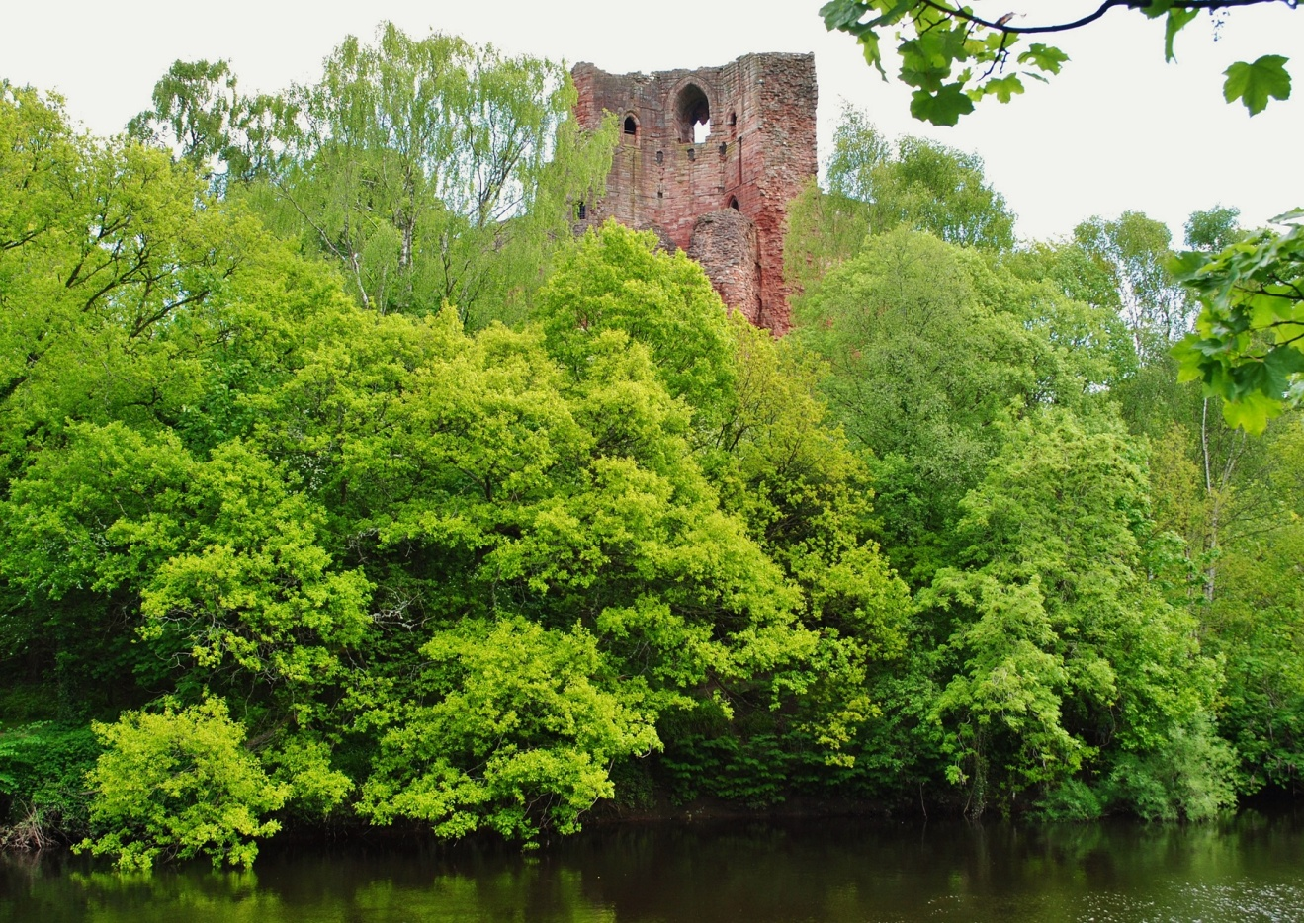

CLUTHA ARCHAEOLOGY GROUP  REPORT: 1  PROJECT ID: 1  DATA STRUCTURE REPORT | Bothwell LNR  Desk-based Assessment  Bothwell, South Lanarkshire

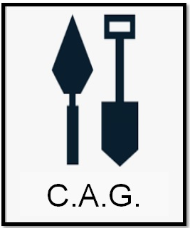

CLUTHA Archaeology Group
Insert postal contact details
web: insert contact details | tel: insert contact details
email: insert contact details

South Lanarkshire Local Nature Reserve
Bothwell, South Lanarkshire
NGR: NS 69010 59028

Desk Based Assessment
in partnership with
South Lanarkshire Council Ranger Service
&
Northlight Heritage

Cover Plate: Bothwell Castle from the Priory site

Report by: Insert Name
Illustrations by: Insert Name
Project Management: Insert Name

Approved by:
Date: | Insert Name  10/26/2020

Contents

1. Introduction 5
2. Site Location 5
3. Aims and objectives 5
4. Methodology 5
5. Results 6
HER, NMRS & Historic Environment Scotland Data 6
Historic Mapping 8
Documentary Sources 9
Aerial Photography 9
Walkover Survey 9
6. Conclusion 9
7. Recommendations 10
8. Bibliography 10
9. Appendices 11
APPENDIX 1 Tables 11
Table 1: Site Gazetteer 11
Table 2: Map Sources Consulted 80
Table 3: Aerial Photographs Consulted at NCAP 80
APPENDIX 2 DES 81

Figures

Figure 1: Location plan 4
Figure 2: Location of archaeological sites 7

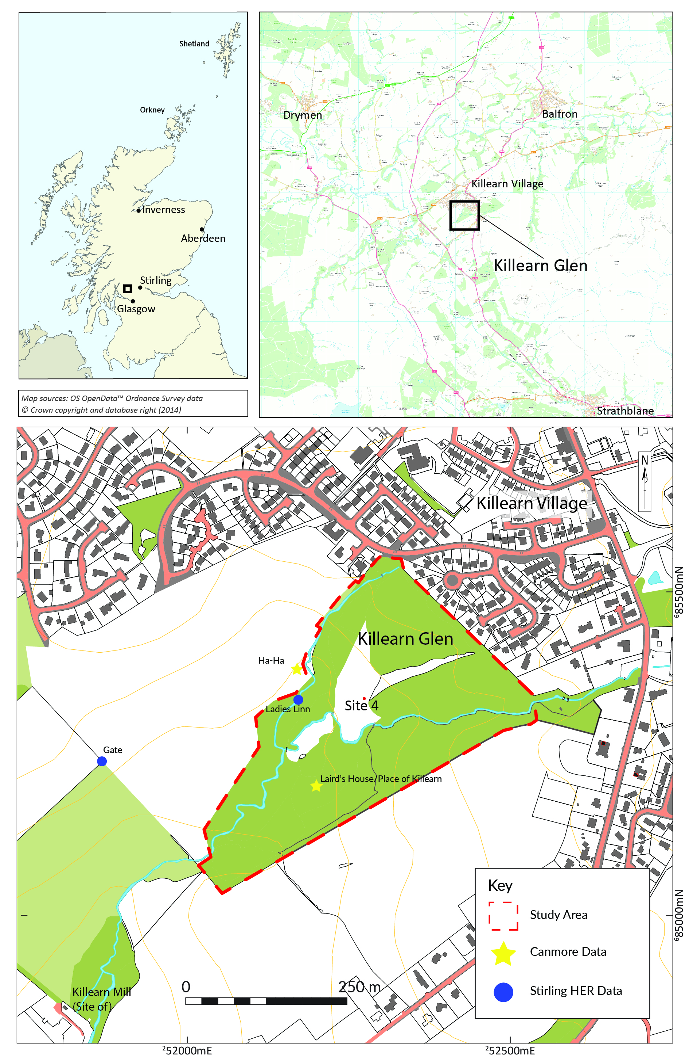
Figure 1: Location plan
Abstract
An archaeological desk-based assessment of Bothwell Local Nature Reserve (LNR) was undertaken by CLUTHA Archaeology Group. The assessment has been undertaken as part of an initiative, in partnership with South Lanarkshire Council Countryside and Greenspace Service (CAG) and Northlight Heritage, to assess the historic environment and bio-cultural heritage significances of South Lanarkshire Local Nature Reserves and proposed Local Nature Reserves and inform the development of appropriate management plans. The assessment, undertaken in xxx 20xx, found that xxxx : summarise key finding. Mention key management issues and recommendations.

1. Introduction

1.1
This report presents the results of a desk-based assessment and walkover survey undertaken in relation to Bothwell Local Nature Reserve. The assessment has been undertaken as part of an initiative, in partnership with South Lanarkshire Council Countryside and Greenspace Service (CAG) and Northlight Heritage, to assess the historic environment and bio-cultural heritage significances of Lanarkshire Local Nature Reserves and proposed Local Nature Reserves and inform the development of appropriate management plans. The assessment was carried out by CLUTHA Archaeology Group and was undertaken during xxx 20xx.

2. Site Location

2.1
The Bothwell Local Nature Reserve is located to the south of the town of Bothwell, South Lanarkshire, centred on approximately NGR: NN 6312 0700 (Figure 1). It comprises wooded slopes and terraces on the north and south side of the River Clyde and is currently being used as xxxx. The study area measures approximately 3 hectares in size. Its solid geology comprises xxxx and its drift geology is xxxx (BGS reference).

3. Aims and objectives

The overall objectives of the Lanarkshire Local Nature Reserve Assessment are expressed in LNR Historic Environment Framework (MacGregor, McGinley & Smith 2020) as:
- To identify and better understand the archaeological, built and bio-cultural heritage features which form the Historic Environment of LNRs and to produce an overall narrative of their history and significance.
- To properly support volunteers in opportunities to learn from and enjoy undertaking the assessment.
- To enhance the Historic Environment Record and to identify future management needs and interpretative opportunities.
- To seek opportunities for learning about and integration with the natural elements of local nature reserves which contribute to the character of the Historic Environment.
The aims of the desk based study were to:

- Indentify any previously recorded or currently unrecorded sites or features present within the Local Nature Reserve;

- Identify any previously recorded archaeological, historic environment and bio-cultural heritage remains within 0.5 km of the Local Nature Reserve boundary in order to provide an overall context to the site;

- Disseminate the results of the study, including DES and OASIS reporting and submission of HER data to WoSAS.

4. Methodology

4.1

The study was delivered in accordance to the relevant Standards and Guidance of the Chartered Institute for Archaeologists (CIfA) including Standard and Guidance for Historic Environment Desk-based Assessment (2017).

The desk-based assessment encompassed the extent of the Local Nature Reserve and the area 0.5 km around it (Figure 2). Sources and information consulted as part of the assessment included the following:

- Information on Scheduled Monuments (SMs), Listed Buildings (LBs), Conservation Areas (CAs), Gardens and Designed Landscapes (GDLs) and Historic Battlefields (HBs) was obtained from Historic Environment Scotland’s online download facility, allowing accurate plotting of site data into a GIS. This was supplemented by a search of their online database.

- A digital extract of the local Historic Environment Record (HER), maintained by West of Scotland Archaeology Service (WoSAS), was obtained and plotted into a GIS.

- The National Monuments Record of Scotland was consulted through the online PastMap facility (http://pastmap.org.uk). This data was cross-referenced with the HER.

- Relevant aerial photographs were viewed at the National Collection of Aerial Photography (NCAP) in Edinburgh in order to identify any unknown sites or features of archaeological interest. These vertical and oblique photographs, ranging in date from 1946 to 1988.

- Digital versions of pre-Ordnance Survey (OS) maps and the first, second and subsequent editions of the OS maps of the area of interest, held by the National Library of Scotland, were identified online and examined. Relevant maps range in date from the eighteenth to the early twentieth century. (an appendix of map regression could be useful for each site or incorporate extracts in text as illustrations)

- Readily accessible primary and secondary historical sources on the area were consulted for information on its history and past land use, including the First and Second Statistical Accounts for Scotland. Lets chat further about this

- The Ancient Woodland Inventory (AWI), The Scottish Forestry online Map Viewer, Scottish Forestry Land Information Search (LIS), Woodland Trust - Ancient Tree Inventory will be consulted for information on veteran trees. Any evidence for Orchards and Greenhouses on historic maps will be checked too.

5. Results

5.1
This assessment identified x archaeological and historic environment sites and features within the Local Nature Reserve boundary. Within 0.5 km of it a total of x sites were noted although many of these were listed buildings within Bothwell itself. Overall these sites place provide a wider context for understanding the significances of the reserve, and help identify associated management and interpretative opportunities.

5.2
Full details of all archaeological sites identified within 0.5 km of the Local Nature Reserve boundary are given in Table 1, Appendix 1 and their locations shown on Figure 2. A summary of the results are given below.

HER, NMRS & Historic Environment Scotland Data

5.3
Examination of the HER, NMRS and Historic Environment Scotland data showed that x previously recorded archaeologically remains were present within the Local Nature Reserve boundary. A further, x sites have been noted within 0.5 km (Figure 2).
18
1

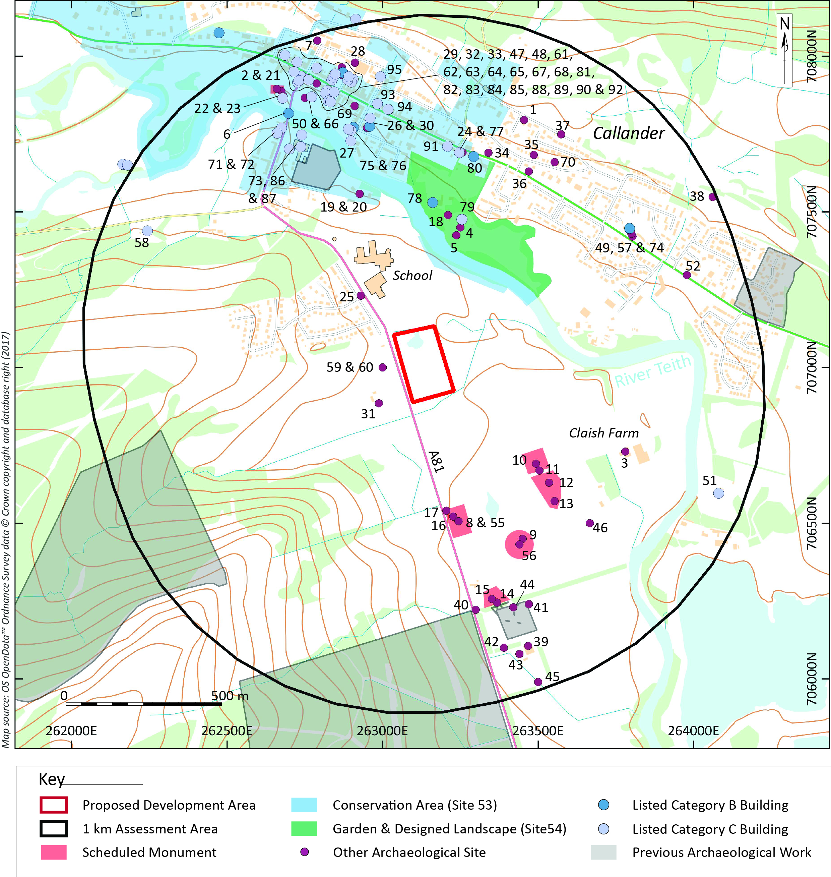

Figure 2: Location of archaeological sites

5.4
Narrative of sites identified from HER / NMRS in reserve (Figure 2). Order by main chronological periods and narrate at a high level.

5.5 Prehistoric

5.6 Early Historic

5.7 Medieval

5.8 Post-Medieval

5.9 Now narrative about sites in buffer by period too.

5.10

Historic Mapping

5.11
Cartographic sources give xxx indication of activity within the Local Nature Reserve .

Documentary Sources

5.12

Documentary sources reveal xxx

Aerial Photography

5.13
Aerial photography of the Bothwell Local Nature Reserve area held in the National Collection of Aerial Photography (NCAP) was consulted on the xxx xxxx 20xx. Photographs from x sorties were examined dating from 1946 to 1988 (see appendix 1, Table 4). Report at high level about any previously unknown features or sites identified or additional information gathered about known sites.

Bio-cultural Heritage

5.13
We can consider veteran trees, pollarded and coppiced trees, old hedge lines, orchards and shrubs such a Rhododendron.

6. Conclusion

6.1
The desk-based assessment reported on above has shown that xxx are present within the boundary of the Local Nature Reserve.

6.2

7. Recommendations

7.1

7.2

8. Bibliography

MacGregor, G, McGinley, C & Smith, A 2020 South Lanarkshire Nature Reserves Historic Environment Programme CLUTHA Volunteer Baseline Assessment Framework. Unpublished Project Design.

Please use Harvard system.

9. Appendices

APPENDIX 1 Tables

Table 1: Site Gazetteer

Site No. | Listed Building | Scheduled Monument | Canmore ID | HER ID | Garden & Designed Landscape | Classification | Name | E | N | OS NGR | Description
1
2
3
4
5
6
7
8
9
10
11

Table 2: Map Sources Consulted

Cartographer | Name | Date Surveyed/Revised | Date Published
William Roy | Roys Military Map Of Scotland: Highlands | n/a | 1747-1752
Ordnance Survey | 25” | 1862 | 1866
Ordnance Survey | 6” | 1862-63 | 1866
Ordnance Survey | 1” | 1859-63 | 1887

Table 3: Aerial Photographs Consulted at NCAP

Library Reference | Sortie | Frame(s) | Date
B 0122 | CPE-UK-0194 | 2305 | 1946
B 0230 | 541-A-0396 | 3385 | 1948
B 0313 | 541-A-0522 | 3125 | 1950
B 0454 | 58-2642 | 0096 | 1958
C 0271 | ASS-51188 | 0159 | 1988

APPENDIX 2 DES

LOCAL AUTHORITY: | South Lanarkshire Council
PROJECT TITLE/SITE NAME: | Bothwell Proposed Local Nature Reserve Assessment
PROJECT CODE: | 1
PARISH: | Bothwell
NAME OF CONTRIBUTOR:
NAME OF ORGANISATION: | CLUTHA Archaeology Group
TYPE(S) OF PROJECT: | Desk Based Assessment
NMRS NO(S):
SITE/MONUMENT TYPE(S):
SIGNIFICANT FINDS:
NGR (2 letters, 8 or 10 figures)
START DATE (this season)
END DATE (this season)
PREVIOUS WORK (incl. DES ref.) | none
MAIN (NARRATIVE) DESCRIPTION:  (May include information from other fields) | You can generally use the abstract for this if not too long.
PROPOSED FUTURE WORK:
CAPTION(S) FOR ILLUSTRS:
SPONSOR OR FUNDING BODY:
ADDRESS OF MAIN CONTRIBUTOR:
EMAIL ADDRESS:
ARCHIVE LOCATION (intended/deposited) | National Monuments Record for Scotland (intended)

